**RETAIL SALES PREDICTION**

**SUPERVISED MACHINE LEARNING - REGRESSION**

**Ajit Varpe, Harisha Chennozwala, Niharika Soni, Satya Prakash**

**Data science trainees**

**AlmaBetter, Bangalore(**[**https://www.almabetter.com/**](https://www.almabetter.com/)**)**

**_________________________________________________________**

**Abstract:** In the following project, we have applied machine learning to a real world problem of predicting retail stores sales. Such predictions help store managers in creating effective staff schedules that increase productivity. We used the popular open source programming language Python and used its libraries like NumPy, scikit-learn, pandas , matplotlib for modelling, analysis and prediction and visualization. We used feature selection, model selection to improve our prediction result. In view of the nature of our problem, Root Mean Square Error (RMSE) is used to measure the prediction accuracy.

**Keywords**: Sales Prediction, NumPy, scikit-learn, machine-learning, RMSE, Linear regression,

1. **Introduction: Please add your introduction & conclusion.**
2. **Dataset and Features**

Training data consists of two parts. One part is historical daily sales data of each store from 01/01/2013 to 07/31/2015. This part of data has about 1 million entries. Data included multiple features that could impact sales. Table 1 describes all the fields in this training data.

**Table 1: Historical sales data table features**

| **Field Name** | **Description** |
| --- | --- |
| Store | a unique Id for each store: integer number |
| DayofWeek | the date in a week: 1­7 |
| Date | in format YYYY­MM­DD |
| Sales | the turnover for any given day: integer number (This is what to be predict) |
| Customers | the number of customers on a given day: integer number (this is not a feature. Based on the data set from AlmaBetter site, this feature is not included in dataset) |
| Open | an indicator for whether the store was open: 0 = closed, 1 = open |
| Promo | indicates whether a store is running a promo on that day: 0 = no promo, 1 = promo |
| State Holiday | indicates a state holiday. Normally all stores, with few exceptions, are closed on state holidays. Note that all schools are closed on public holidays and weekends. a = public holiday, b = Easter holiday, c = Christmas, 0 = None |
| School Holiday | indicates if the (Store, Date) was affected by the closure of public schools: 1 = school holiday, 0 = not school holiday |

The second part of training data is supplement store information. It has 1115 store info entries, which listed the store type, competitor and a different kind of promotion info. Table 2 below describes all the fields in this file.

**Table 2: Store Information data table features**

| **Field Name** | **Description** |
| --- | --- |
| Store | a unique Id for each store: integer number |
| StoreType | differentiates between 4 different store models: a, b, c, d |
| Assortment | describes an assortment level: a = basic, b = extra, c = extended |
| CompetitionDistance | distance in meters to the nearest competitor store |
| CompetitionOpenSinceMonth | gives the approximate year and month of the time the nearest competitor was opened |
| CompetitionOpenSinceYear |
| Promo2 | Promo2 is a continuing and consecutive promotion for some stores: 0 = store is not participating, 1 = store is participating |
| Promo2SinceWeek | describes the year and calendar week when the store started participating in Promo2 |
| Promo2SinceYear |
| Promo Interval | describes the consecutive intervals Promo2 is started, naming the months the promotion is started anew. E.g. "Feb,May,Aug,Nov" means each round starts in February, May, August, November of any given year for that store |

**Dataset Statistic:**

| **STATISTICS** | **NUMBERS** |
| --- | --- |
| Rossmann Dataset size | 1017209 |
| Total stores number | 1115 |
| Rossmann data Time ranges | 2013-08-01 to 2015-07-01 |

We did several things to combine features and create features directly related to sales numbers. The work we did is:

1. The supplement store information can’t be used directly. We merged store information and historical sales data. Store type and Assortment is merged into each entry of historical sales data

2. Combine Promo2, Promo2SinceWeek, Promo2SinceYear and Promointerval to a promotion 2 indicator in historical sales data. The indicator indicates on a certain day whether a certain store is on promotion 2.

3. Similarly, we combined CompetitionDistance, CompetitionOpenSinceMonth, CompetitionOpenSinceYear to a competitor indicator. The indicator indicates on a certain day whether a certain store has a competitor.

4. Since CompetitionDistance is provided, we used CompetitionDistance to train the model, instead of competitor indicator. For any date and any store which doesn’t have a competitor (competitor==1), we assign CompetitionDistance as a large number 100000. This method enables us to use only one CompetitionDistance feature. It also models the no competitor case by weakening CompetitionDistance impact.

5. Historical sales dataset has Date feature. We created a Month and Year feature based on the Date feature. Month and Year are used as features, since they correlate with sales data.

The final training dataset used includes the following features.

| StoreID | Open | Promo2 indicator |
| --- | --- | --- |
| DayOfWeek | StateHoliday | Store Type |
| Month | SchoolHoliday | Assortment |
| Year | Promo | CompetitionDistance |

1. **Literature review:**

Forecasting is projecting, predicting or estimating some future condition or event that is beyond an organization’s power and gives a basis for efficient planning. Forecasting is necessary for several situations of modern business and its proper working. Organizations must make plans that will be efficient at some point in the future. And to do this they require information and data about current circumstances. It is very unfortunate that though forecasting is an important aspect yet its progress in many fields or research and development has been limited. In the past decade Machine Learning has emerged as a technology with a great promise for identifying and modeling data patterns that are not easily described by traditional statistical methods in a field as diverse as cognitive science, computer science, electrical engineering and finance. Example- studies in the "finance literature evidencing predictability of stock returns by means of linear regression can be improved by a neural network. Machine Learning has also been increasingly used in management, marketing and retailing. The types of applications include market response forecasting. In this particular project we will give the following business insights to the owner

• What is the extent to which sales performance is influenced by factors like: promos, school and state holidays, competition distance ,competition open month. locality and seasonality,

• What model is appropriate to predict sales?

**4. Problem Formulation:**

Rossmann store managers had to predict the daily sales and the number of customers for up to six weeks in advance; while store sales, What is the extent to which sales performance is influenced by factors like: promos, school and state holidays, competition distance ,competition open month. locality and seasonality,

As there are so many individuals who try to forecast sales based on their unique sets of circumstances, the accuracy of such forecasts was rather varied. So our task was to make an efficient machine learning model that would predict the sales for 1,115 stores across Germany using which store managers would be able to create effective staff schedules to increase their productivity and sales turnover.

We are given a dataset from Rossman inc. An algorithm that will predict the quantity of sales. The evaluation metric for this problem is RMSE. The RMSE calculated as follows:

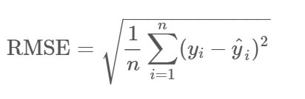

**5. Future scope of the project**

Our model will help local retailers to spike their business in the following ways:-

1. It will help them to decide marketing strategies.
2. It will help them prepare the budget and for setting financial policies.
3. With an effective sales forecast it is feasible to obtain an average estimate of everything in such a way that the average manpower and plant capacity is fully utilized during the entire time period. Thus the forecasting enables us to overcome seasonal variations.
4. It helps in organizing stocks and prevents the risk of both overstocking and understocking.
5. With the help of forecasts we can find out which product provides more profit and which product’s manufactured should be stopped.

We believe every business will at some point in the future consider forecasting their sales for the upcoming challenges.

**6. Analysis & Exploration:**

In the following section we try to analyze our dataset and figure out what are the most important features for our predictive model out of useful features that can be used to forecast sales. At first we perform the feature extraction from our dataset and take out the derived values from the existing data given to us. Then, to get more important features, the store information is reviewed. At the end , we will try to figure out more information from store information.

**Open**

"Open" indicates if this store is open or not on a given specified day. Because the sales of the store must be 0 if it is closed, we removed the data point with (null value removal to reduce bias )"Open = 0" and after prediction, we will replace the value of sales as 0 for the data point with "Open = 0" in testing data.

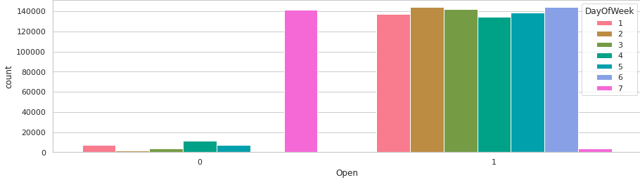

It clearly shows that most of the stores remain closed during Sundays. Some stores were closed on weekdays too, this might be due to State Holidays as stores are generally closed during State Holidays and opened during School Holidays.

**Year**

The sales have a relationship with years, as the brand influence, marketing and other strategies of this company may vary from year to year, which could possibly have an impact on the sales.

**Month**

As people are more prone to having cold and other medical conditions during the winter and more sun related issues like dehydration and sunstroke during summer, people would have different demands for drugs during different months. So, the sales are possibly affected by the month of the particular year.

**Day**

Each single day could affect the sales. For instance, there may be people who tend to buy drugs on the first day of month or they might go to stores when they get their salary. So, days must also play a role in the sale pattern.

**Store ID**

Store ID is one unique feature as every store has its own different id’s. Sales may or may not change from store to store. If we use Store ID as a feature, we observe that the correlation coefficient of Store ID and Sales is 0.005.

## **Average Sales & Sales percent change; Average sales over time(year-month)**

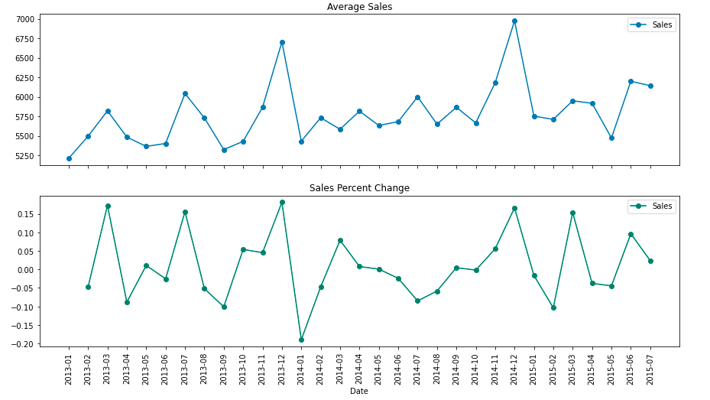

It is also interesting to note that Christmas and New Year(the above graph at weeks near 52) lead to increase in sales. As Rossmann Stores sells health and beauty products, it may be guessed that during Christmas and New Year people buy beauty products as they go out to celebrate and, this might be the cause of sudden increase in sales.

## **Average sales & customers for every year**

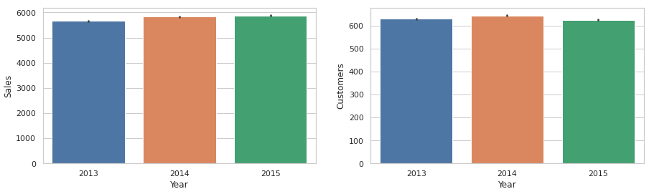

## **DayOfWeek**

On different days of week, each store will have different sales as people get used to shopping on different days. This particular feature plays a significant role in the sales prediction.

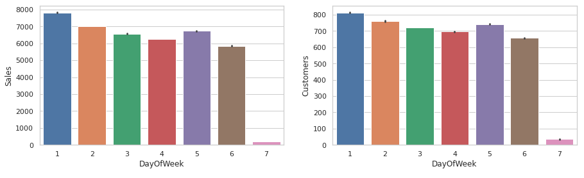

DayOfWeek for both Sales and Customers are very less on Sundays as most of the stores are closed on Sunday. Also, Sales on Monday are the highest in the whole week. This might be due to the fact that stores are closed on Sundays.

## 

## 

## 

## **StateHoliday**

Different People have different demands and needs for drugs during holidays. We have information on state holiday, school holidays for each store every day. There is some correlation between state holidays and sales.

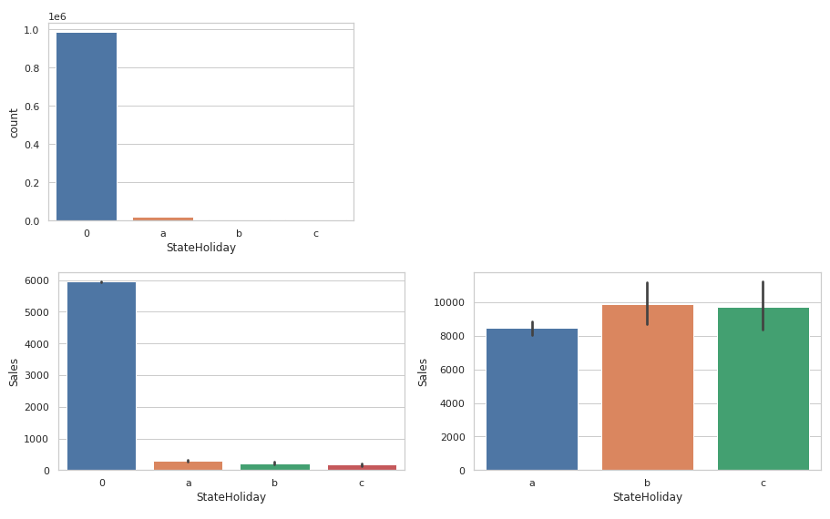

We have StateHoliday as Objects we need to convert them to numerical categories:

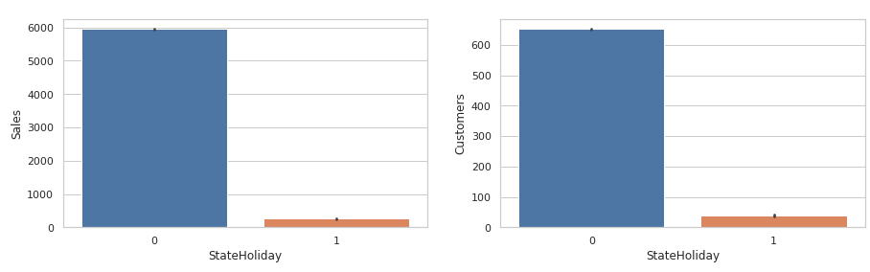

Most of the stores remain closed during State and School Holidays. The number of stores opened during School Holidays were more than those opened during State Holidays. And the stores which were opened during School holidays had more sales than normal.

## **Sales affected by SchoolHoliday or not?**

On examining the effect of school holiday on the effect of sales we can see the impact is not so significant.

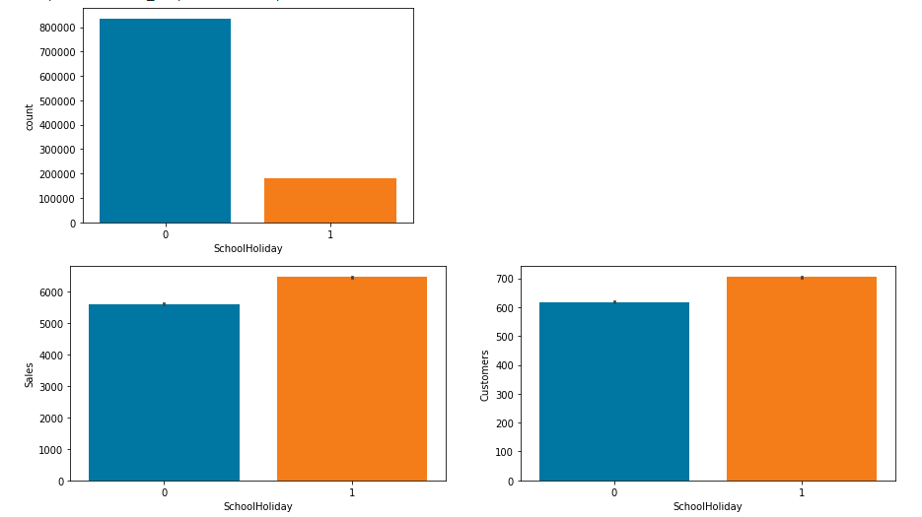

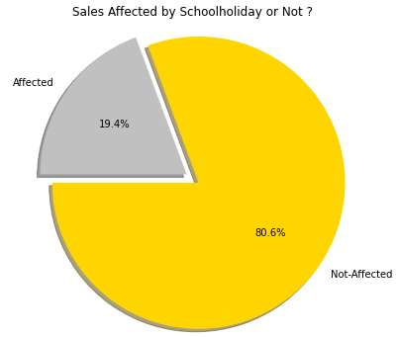

We can observe that most of the stores remain closed during State and School Holidays. But it is interesting to note that the number of stores opened during School Holidays were more than those that were opened during State Holidays.

Another important thing to note is that the stores which were opened during School holidays had more sales than normal.

## 

## **Sales by StoreTypes**

Because different stores have different assortment level, We check the percentage of sale of different types of store based on assortment we can see that the store type-a has the most powerful impact on the sale

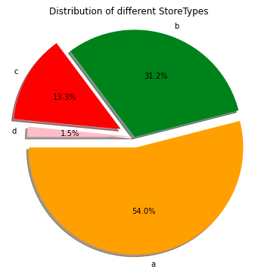

We can see that stores of type A have a higher amount of total Customers and Sales. StoreType D goes on the last place in both Sales and Customers.

**StoreType Vs average sales and customers**

The best way to understand the performance of a store type is to see what the sales per customer is so that we normalize everything and we get the store that makes its customers spend the most on average.

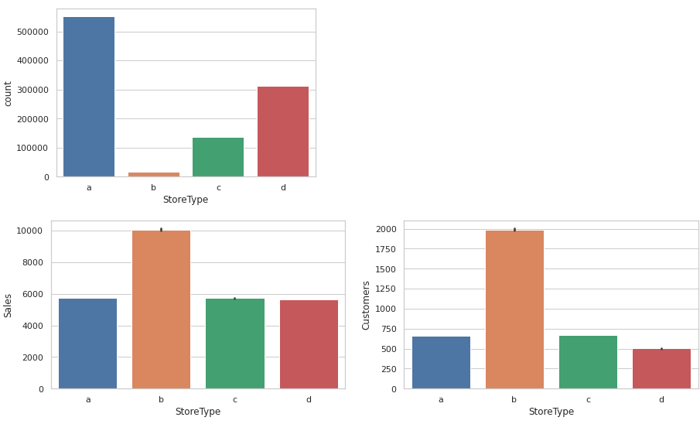

We can see that Storetype A has the highest number of branches,sales and customers from the 4 different store types. But this doesn't mean it's the best performing Storetype.

When looking at the average sales and number of customers, we see that actually it is Storetype B who has the highest average Sales and highest average Number of Customers. One assumption could be that if B has only 17 stores but such a high amount of average sales and customers that it is likely hyper Rossmann branches whereas A would be smaller in size but much more present.

## **Assortment & Assortment Vs average sales and customers**

As we cited in the description, assortments have three types and each store has a defined type and assortment type:

* a-means basic things
* b-means extra things
* c-means extended things so the highest variety of products.

What could be interesting is to see the relationship between a store type and its respective assortment type.

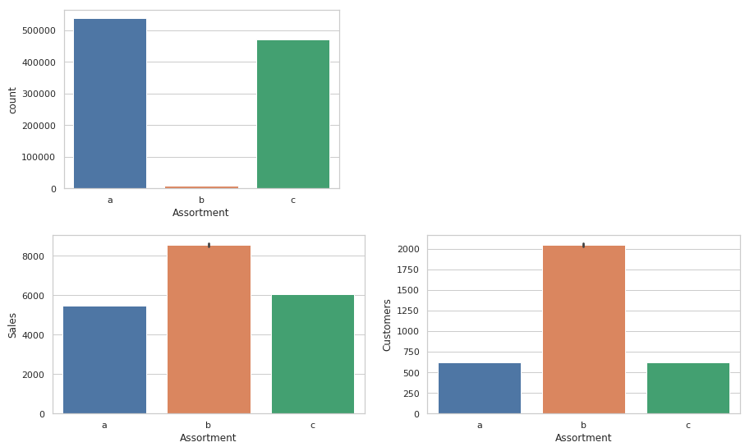

We can clearly see here that most of the stores have either an assortment type or c assortment type.

Interestingly enough, assortment type B has maximum sales and customers.

## **CompetitionDistance**

People will obviously prefer going to the store which is closer to their location. Their competition distance can also affect the sale of a store.

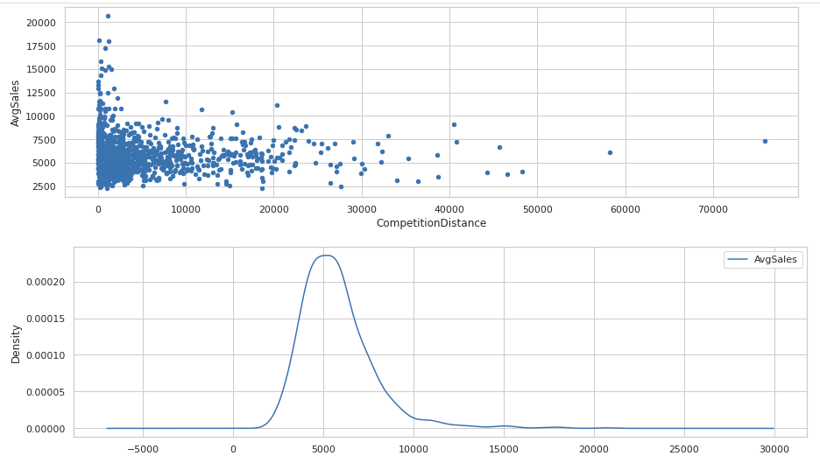

The stores that are the furthest have the highest average sales and number of customers. Drop in Sales observed as the competition opens. We can clearly observe that most of the stores have their competition within 5km range.

**The average sales of a store over time when competition started.**

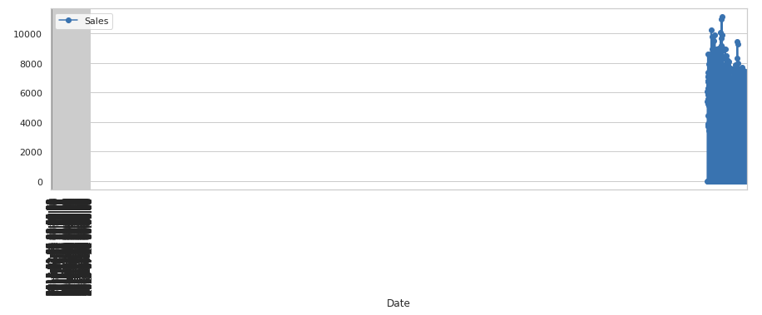

As we can see here, the stores that are the furthest have the highest average sales and number of customers. We can clearly observe that most of the stores have their competition within 5km range.

This doesn't automatically mean that the furthest the better, but it does shed light on the fact that when there is no competition nearby, stores tend to sell more and have more customers because there is almost a monopoly in this region. We could think of it as McDonalds on highways where there are no other restaurants around, people who are hungry are forced to go there to eat.

## **Sales by Season**

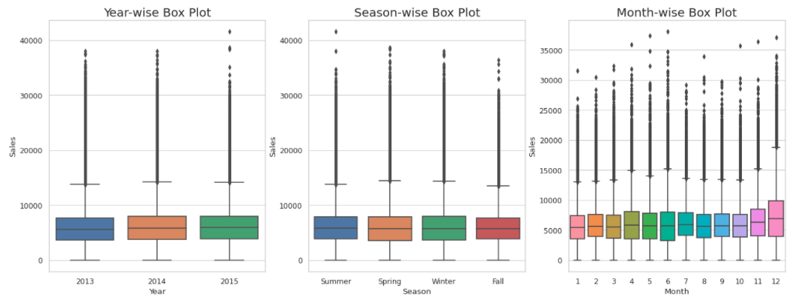

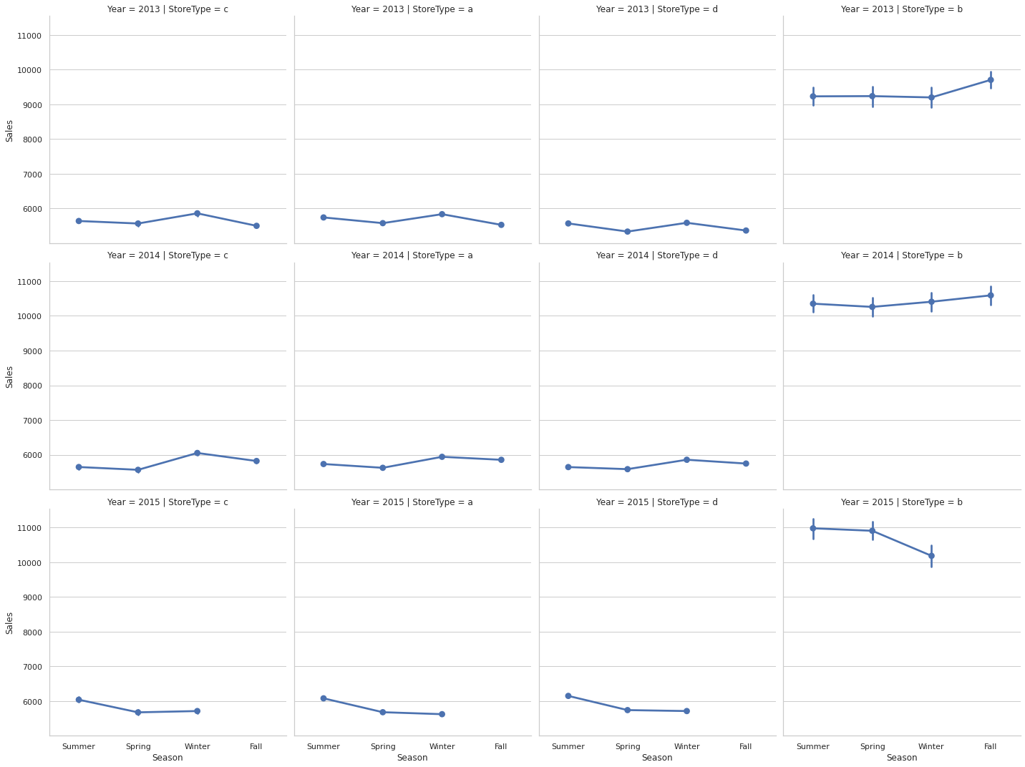

## 

We observe that Santa Claus has a special blessing on Rossmann Stores' which means in the month of December sales increases.

## **Effect of Promotion on sales & Customers**

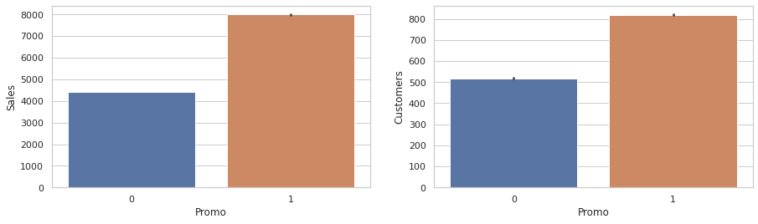

## 

## 

## **Promo2 & Promo2 Vs average sales and customers**

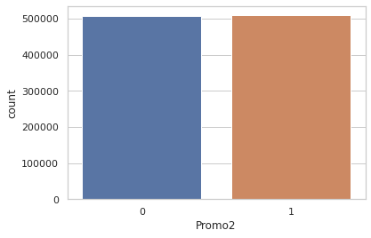

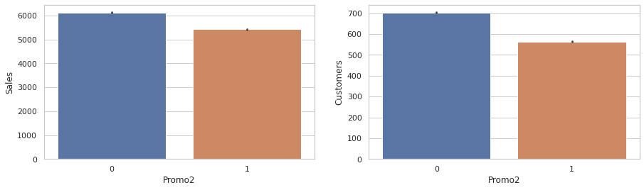

Customer over promotion we understand that initially those stores suffer from low sales and those continuous promotions show a tremending increase in the buying power of customers.

We can see that both Sales and Customers increase by a significant amount during Promotions. This shows that Promotion has a positive effect for a store.

**Effect on sales after first and second promotion**

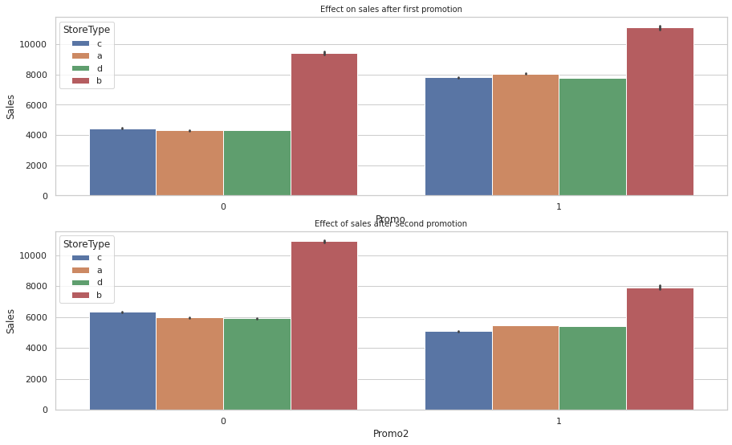

First promotion has a positive effect on sales, but the second promotion has a negative impact on sales.

**Risk Analysis**

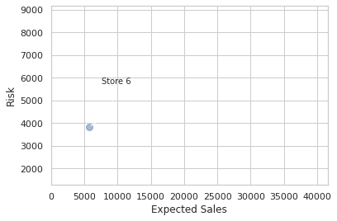

Forecast not only more probable values of sales but also their distribution. Especially we need it in the risk analysis for assessing different risks related to sales dynamics.

# **Sales & Customers Distribution**

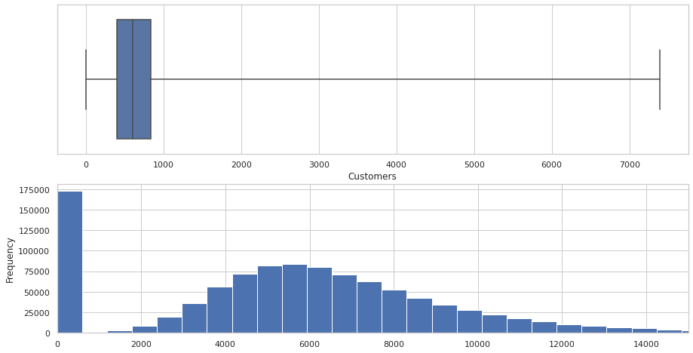

Sales that values with 0 is mostly because the store was closed. Sales is highly correlated to the number of Customers.

# 

# 

# 

# 

# **Correlation Heatmap**

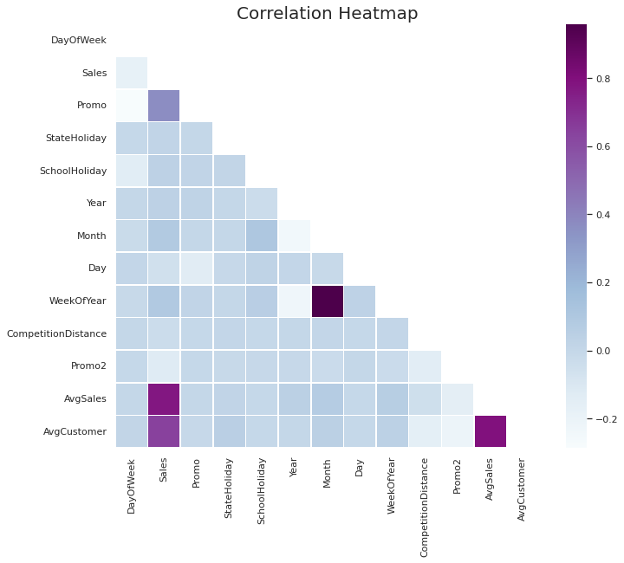

1. Average Customers and Average sales are positively correlated between 0.8
2. Sales and Promo ( more than 0.2) actually correlate positively
3. Sales correlates with Competition Distance(more than 0.1), in a positive manner
4. Promo also effects sales positively

### **Interpretation:**

We can first see the 0.8 between AvgCustomers and Average sales which suggests that they are positively correlated like we stated above in the analysis.

It's interesting to see that Sales and Promo ( more than 0.2) actually correlate positively, since running a promotion increases that number .

Sales correlates with Competition Distance(more than 0.1), in a positive manner, like we said up the higher the competition distance the more sales per customer we do, which makes sense , the further our competition, the more monopolization Rossman can achieve in the region.

Additionally, the effect of promo to Sales like we said above as well(about 0.4), it did provoke a change in the buying pattern and increased it when continuous promotions were applied.

# **Feature Engineering**

Since we need numerical variables for both our correlation Analysis and to feed the models, we need to transform what is not numerical to a numerical representation while keeping the logic behind it present. For this we did the below mentioned steps for model training:

## 1 Remove features with high percentages of missing values

## 2 Drop Subsets Of Data Which Might Cause Bias

## 3 Create a new variable "AvgSales" . Create a variable that calculates monthly average sales for each store.

## 4 Transform Variable "StateHoliday"

### **Conclusion of Exploratory Analysis:**

At this stage, we got a solid understanding of the distributions, the statistical properties and the relationships of our variables. The next step is to identify what variables to model for training and to work on the modeling part of the project

# **Store Sales Prediction**

Sales prediction is rather a regression problem than a time series problem. Practice shows that the use of regression approaches can often give us better results compared to time series methods. Machine-learning algorithms make it possible to find patterns in the time series. We can find complicated patterns in the sales dynamics, using supervised machine-learning methods.

Some of the most popular are tree-based machine-learning algorithms , e.g.,- Random Forest, Decision Tree etc . One of the main assumptions of regression methods is that the patterns in the past data will be repeated in future. In the sales data, we can observe several types of

patterns and effects. They are: trend, seasonality, autocorrelation, patterns caused by the impact of such external factors as promo, pricing, competitors’ behavior. We also observe noise in the sales. Noise is caused by factors which are not included in our consideration. In the sales data, we can also observe extreme values—outliers. If we need to perform a risk assessment, we should take into account noise and extreme values. Outliers can be caused by some specific factors, e.g., promo events, price reduction, weather conditions, etc. If these specific events are repeated periodically, we can add a new feature which will indicate these special events and describe the extreme values of the target variable.

**Train-Test Split**

We have split our variables into training and testing sets. We have performed this by importing train_test_split from the sklearn.model_selection library. It is usually a good practice to keep 70% of the data in your train dataset and the rest 30% in your test dataset.

**Machine Learning Data Modeling (for our Prediction)**

We need to build a Machine Learning model that will forecast future sales. Various methods of sales forecasting model that we will use in our project includes:

## **Linear Regression (OLS)**

**Ordinary Least Squares**  is a method which helps us estimate the unknown parameters in the Linear regression model. How does it estimate the parameters though? Well, it estimates the parameters by minimizing the sum of squared residuals. The way it does this is , it draws a line through the data points such that the squared differences between the observed values and the corresponding fitted value is minimized.

Linear regression attempts to model the relationship between two variables by fitting a linear equation to observed data. ... A linear regression line has an equation of the form Y = a + bX, where X is the explanatory variable and Y is the dependent variable.

## **Bayesian Ridge Regression**

Bayesian regression allows a natural mechanism to survive insufficient data or poorly distributed data by formulating linear regression using probability distributors rather than point estimates. The output or response ‘y’ is assumed to be drawn from a probability distribution rather than estimated as a single value.

Mathematically, to obtain a fully probabilistic model the response y is assumed to be Gaussian distributed around Xw 𝑋as follows

p(y⏐X,w,α)=N(y⏐Xw,α)p(y⏐X,w,α)=N(y⏐Xw,α)

One of the most useful types of Bayesian regression is Bayesian Ridge regression which estimates a probabilistic model of the regression problem. Here the prior for the coefficient w is given by spherical Gaussian as follows −

p(w⏐λ)=N(w⏐0,λ−1Ip)

p(w⏐λ)=N(w⏐0,λ−1Ip)

This resulting model is called Bayesian Ridge Regression

## **LARS Lasso Regression**

**Least Angle** regression(LARS). Basically, LARS makes leaps in the most optimally calculated direction without overfitting the model.

**Algorithm:**

* Normalize all values to have zero mean and unit variance.
* Find a variable that is most highly correlated to the residual. Move the regression line in this direction until we reach another variable that has the same or higher correlation.
* When we have two variables that have the same correlation, move the regression line at an angle that is in between (i.e., least angle between the two variables).
* Continue this until all of our data is exhausted or until you think the model is big and ‘general’ enough.

Mathematically, LARS works as follows:

* All coefficients, ‘B’ are set to 0.
* The predictor, xj is found to be most correlated to y.
* Increase the coefficient Bj in the direction that is most correlated with y and stop when you find some other predictor xk that has equal or higher correlation than xj.
* Extend (Bj, Bk) in a direction that is **equiangular** (has the same angle) to both xj and xk.
* Continue and repeat until all predictors are in the model.

## **Decision Tree Regression**

Decision trees build regression or classification models in the form of a tree structure. It breaks down a dataset into smaller and smaller subsets while at the same time an associated decision tree is incrementally developed. The final result is a tree with decision nodes and leaf nodes. A decision node (e.g., Outlook) has two or more branches (e.g., Sunny, Overcast and Rainy), each representing values for the attribute tested. Leaf node (e.g., Hours Played) represents a decision on the numerical target. The topmost decision node in a tree which corresponds to the best predictor called root node. Decision trees can handle both categorical and numerical data.

## **Random Forest Regression**

Random Forest Regression is an ensemble learning algorithm that operates by aggregating many random decision trees to make predictions while avoiding overfitting. We started by using the Random Forest algorithm for black box prediction because its bagging techniques are robust to data anomalies (like missing data) and because random forest packages are widely available

## **K-Nearest Neighbors Regression**

## K-NN algorithm assumes the similarity between the new case/data and available cases and puts the new case into the category that is most similar to the available categories. K-NN algorithm stores all the available data and classifies a new data point based on the similarity. This means when new data appears then it can be easily classified into a well suited category by using K- NN algorithm. K-NN algorithm can be used for Regression as well as for Classification but mostly it is used for the Classification problems. K-NN is a non-parametric algorithm, which means it does not make any assumption on underlying data. It is also called a lazy learner algorithm because it does not learn from the training set immediately instead it stores the dataset and at the time of classification, it performs an action on the dataset.

## 

## 

## 

## 

## **Model Comparison & Selection**

## There are two popular metrics used in measuring the performance of regression (continuous variable) models i.e MAE & RMSE.

## Mean Absolute Error (MAE): It is the average of the absolute difference between the predicted values and observed values.

## Root Mean Square Error (RMSE): It is the square root of the average of squared differences between the predicted values and observed values.

## MAE is easier to understand and interpret but RMSE works well in situations where large errors are undesirable. This is because the errors are squared before they are averaged, thus penalizing large errors.

So, we’ll choose RMSE as a metric to measure the performance of our models.

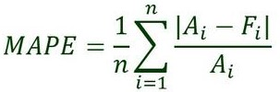

Ai = actual value

Fi = forecast value

n = total number of observations

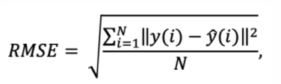

N = number of data points

yi = i-th measurement - Predicted sales.

y ̂(i) = the corresponding prediction - Sales.

**Experiments and Metrics**

| **Model** | **Training MAPE** | **Testing MAPE** | **Training RMSE** | **Testing RMSE** | **Model Score** |
| --- | --- | --- | --- | --- | --- |
| **Linear Regression** | **16.95** | **17.230** | **1546.46** | **1563.75** | **0.7534** |
| **Bayesian Ridge Regression** | **16.95** | **17.214** | **1547.10** | **1562.62** | **0.7534** |
| **LARS Lasso Regression** | **16.953** | **17.214** | **1547.25** | **1562.73** | **0.7534** |
| **Decision Tree Regression** | **12.456** | **14.690** | **1195.66** | **1402.53** | **0.8544** |
| **Random Forest Regression** | **12.456** | **14.690** | **1195.66** | **1402.53** | **0.9779** |
| **K-Nearest Neighbors Regression** | **22.92** | **23.86** | **1915.63** | **1994.32** | **0.6275** |

# **Facebook Prophet Model for Sales Prediction**

The Facebook Prophet package is designed to analyze time series data with daily observations, which can display patterns on different time scales. Prophet is optimized for business tasks with the following characteristics:

hourly, daily, or weekly observations with at least a few months (preferably a year) of history strong multiple “human-scale” seasonalities: day of week and time of year important holidays that occur at irregular intervals that are known in advance (e.g. the Super Bowl) a reasonable number of missing observations or large outliers historical trend changes, for instance due to product launches or logging changes trends that are non-linear growth curves.

According to the "facebook research" website, there are four main components inside the facebook prophet model.

* A piecewise linear or logistic growth trend.
* A yearly seasonal component modeled using Fourier series.
* A weekly seasonal component using dummy variables.
* A user-provided list of important holidays.

The method of combining different models into one makes the facebook prophet model much more precise and flexible.

Now, despite the naive model, we will apply our sales set to the face book model by using the function fbprophet. fbprophet.Prophet can change the value of "changepoint_prior_scale" to 0.05 to achieve a better fit or to 0.15 to control how sensitive the trend is.

We will figure out the best forecasting by changing the value of changepoints.

If we find that our model is fitting too closely to our training data (overfitting), our data will not be able to generalize new data.

If our model is not fitting closely enough to our training data (underfitting), our data has too much bias.

Underfitting: increase changepoint to allow more flexibility Overfitting: decrease changepoint to limit flexibility.

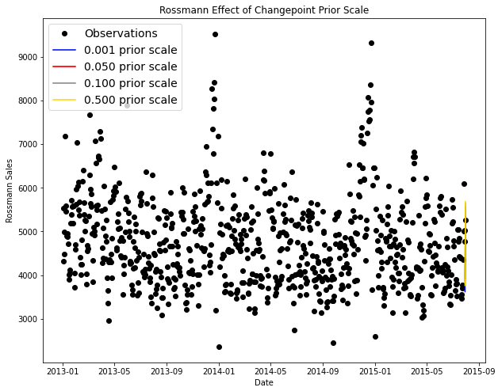

Predictions for 6 Weeks In order to make forecasts, we need to create a future dataframe. We need to specify the amount of future periods to predict and the frequency of our prediction. Periods: 6 Weeks; Frequency: Daily

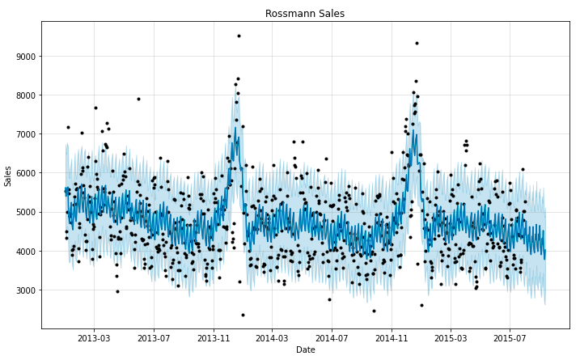

The Prophet plots the observed values of our time series (the black dots), the forecasted values (blue line) and the uncertainty intervals of our forecasts (the blue shaded regions). Looks like Prophet has captured the negative trend and the seasonality from this store sales quite well.

**Facebook Prophet Model - Weekly & monthly seasonalities trend**

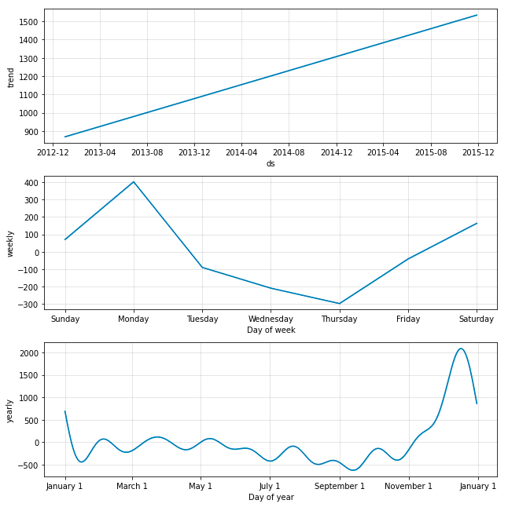

The obvious downward trend seems like this store needs some attention from Rossmann. We can clearly see the drop in sales in the fall months and the spike during Christmas. It is nice to see that this model doesn’t put too much emphasis on the single drop in sales in June 2014. We also get to see the dip in Sales on Thursdays.

**Model selection:**

* As is shown in the result, among all models, **Random Forest** works the best with the higher model score and least RMSE we have, and provides a reliable prediction of the sales.
* Linear regression, Bayesian Ridge Regression, LARS Lasso Regression, Decision Tree Regression, K-Nearest Neighbors Regression all have their own strengths and limitations.
* However, We have listed out the most significant changepoints in our data. This is representing when the time series growth rate significantly changes, while **Facebook prophet model** calculates the best solid result.

**Feature Importance**

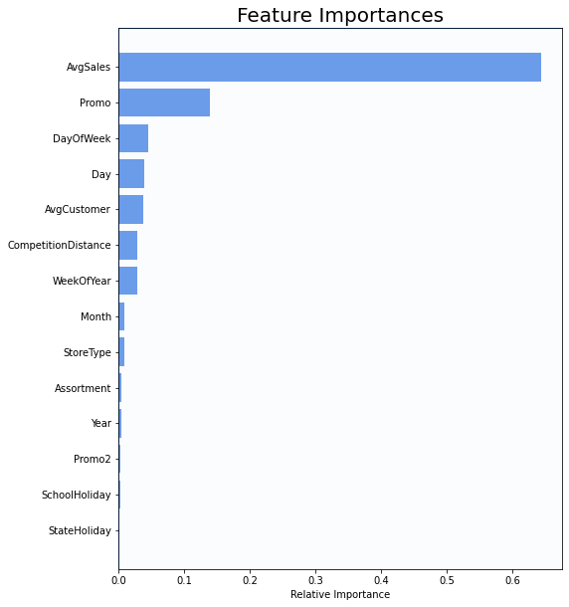The important features in all of the Rossmann stores, organized from most important to least. They are equally weighted across all stores to generate all feature importances in the Rossmann dataset.

**Business Insights & Recommendations:**

* Rossmann should focus on increasing the promotional offers per quarter for a,c,d and can minimize for b.
* The most selling and crowded store type is B
* Sales is highly correlated to the number of Customers.
* For all stores, Promotion leads to increase in Sales and Customers both.
* The stores which are opened during the School Holiday have more sales than normal days.
* ·More stores are opened during School holidays than State holidays.
* Rossman should try to focus on reducing the Promo offers for store type b during StateHolidays as there is no substantial increase in Sales.
* ·Sales are increased during Christmas week, this might be due to the fact that people buy more beauty products during a Christmas celebration.
* Rossmann can divert some of the Promos from being offered on SchoolHolidays to No SchoolHolidays to maximise the Sales revenue.
* ·Absence of values in features CompetitionOpenSinceYear/Month doesn’t indicate the absence of competition as CompetitionDistance values are not null where the other two values are null.
* ·After analysing sales using Fourier decomposition, we found that there’s a little seasonality component in the Sales data.

**CONCLUSION AND FUTURE SCOPE : Please add your conclusion.**